**Project Report: Air Quality Monitoring Dashboard**

**1. Introduction**

This project is a responsive web page designed to monitor and display real-time air quality data. The website uses the OpenWeather API to fetch air quality index (AQI) data for a given city, offering features such as a past 30-day AQI chart, today’s weather, and a 5-day weather forecast. The goal of this project is to create an efficient, responsive, and user-friendly interface that allows users to access environmental data with a focus on air quality measurements.

**2. Tools and Technologies Used**

* **HTML, CSS, and JavaScript:** For creating the structure, styling, and interactive elements of the application.
* **Leaflet:** A JavaScript library for rendering the interactive map.
* **Chart.**js : Used to display AQI data as a chart
* **Air Quality API (OpenWeather):** Used to fetch real-time air quality data and forecasts for various cities.
* **Fetch API:** Used to send HTTP requests and retrieve data from the Air Quality API.
* **Visual Studio Code:** The main code editor for the development of this project.
* **Git and GitHub:** For hosting the project repository.
* **Postman:** Used to test API requests during the development process.

**3. Project Development Process**

**Initial Setup**

* Created the basic layout using HTML and CSS, ensuring the design would be responsive for both mobile and desktop devices.
* Integrated the Fetch API to retrieve data from the Air Quality API based on user input for city names.

**Features Implemented**

1. **Responsive Layout:**
   * The web application is designed to adapt to different screen sizes (mobile, tablet, and laptop).
   * The sidebar functions well on mobile, but some issues remain with the main page and other content pages on smaller screens.
2. **Fetching and Displaying Data:**
   * Users can input a city name in the search bar, and the application fetches and displays AQI data for that city.
   * Displays a 30-day AQI chart along with today’s weather and a 5-day weather forecast.
3. **Error Handling**:

* Managed errors for invalid or unrecognized city names with clear alert messages.

1. **Issues Faced:**
   * **Responsive Issues:** While the sidebar displays correctly on mobile, the main content pages (especially the interactive map) sometimes fail to render properly on smaller screens.
   * **Delay in Data Fetching:** Fetching the 30-day AQI data can take a few seconds, causing a delay in displaying the results.

**4. Successes and Achievements**

* **Data Integration:** Successfully integrated the Air Quality API to fetch and display real-time data, including a 30-day AQI chart and 5-day weather forecast.
* **Responsive Design:** Achieved a mostly responsive layout. The three pages linked from the sidebar (Today’s Weather, Weekly Forecast, and AQI Index & Temperature) work well on both mobile and desktop devices.
* **Visualization**: Used Chart.js to provide clear and interactive AQI trend visualization

**5. Challenges and Failures**

* **Mobile Layout Issues:** While the sidebar works as I intended, the main page and some other pages, such as the interactive map, do not render correctly on smaller screens. This needs further improvement.
* **Performance Delay:** There is a noticeable delay in fetching data for the 30-day AQI chart.

**6. Guide to the Website**

**Main Page**

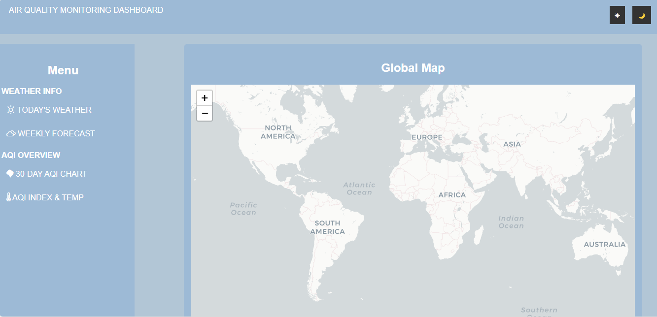

* The main page includes an interactive global map as a decorative feature.
* At the top right corner, there are **Day Mode** and **Night Mode** buttons for toggling the background color between white and black.

|  |  |
| --- | --- |
|  |  |

**Today’s Weather**

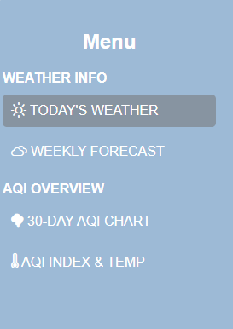 When a user clicks TODAY'S WEATHER from the Menu bar,

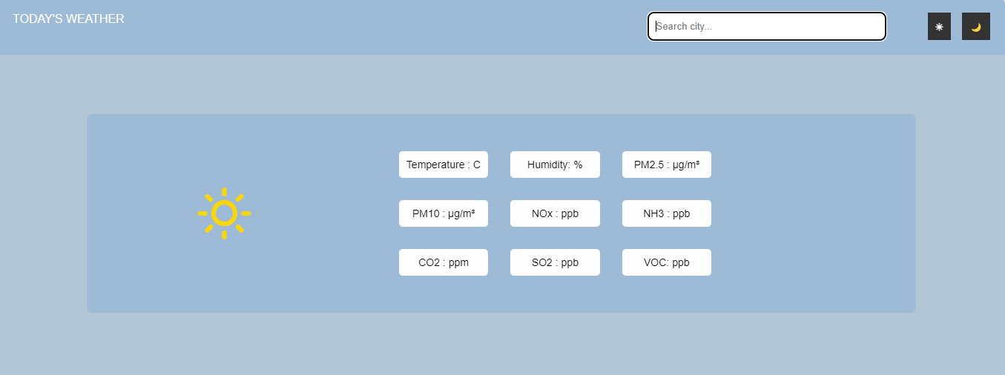

the user can search for a city using the search bar. After entering a city name, weather data for that city is displayed, including temperature and weather conditions.

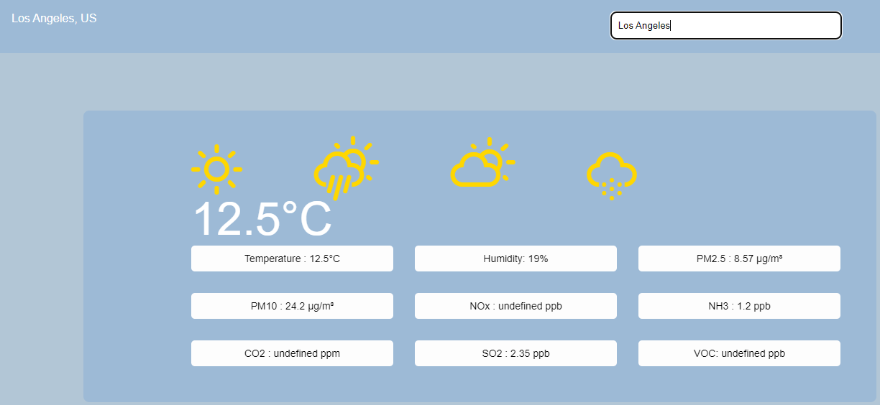

**WEEKLY FORECAST**

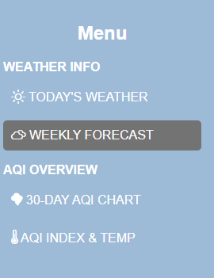

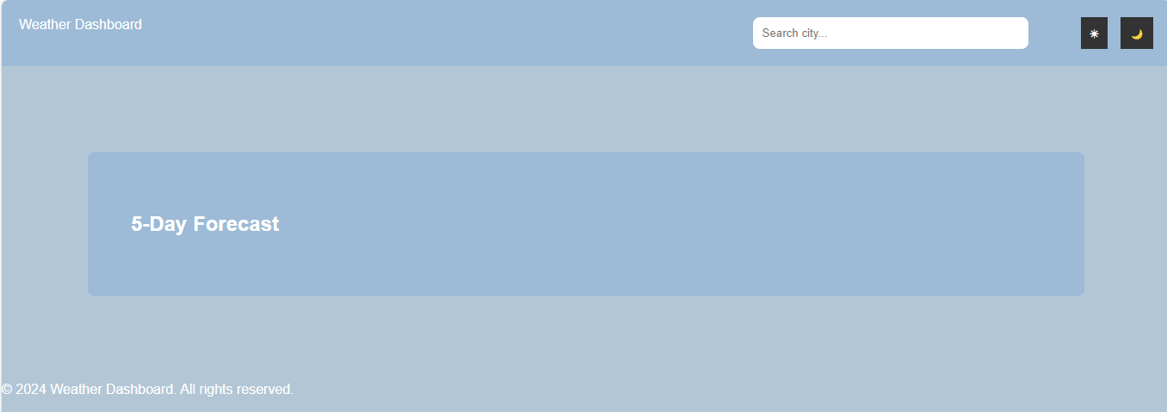Before searching for a city, the page displays default weather data.

After entering a specific city name in the search bar, the weather forecast for the next five days is can be seen as below. 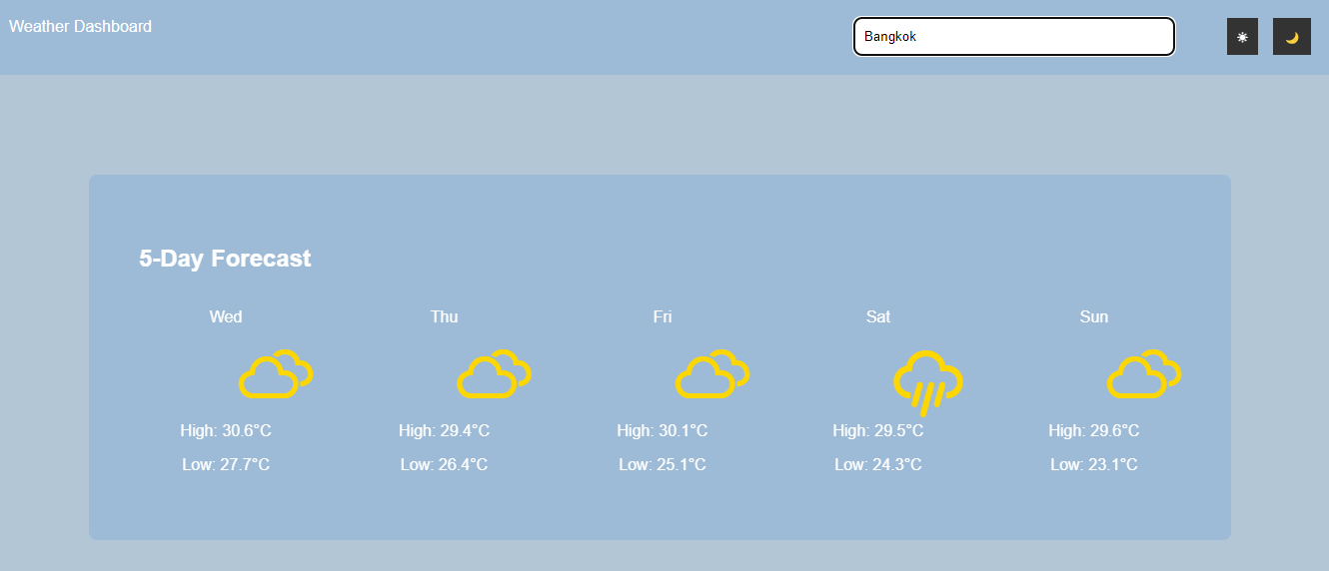

**30-Day AQI Chart**

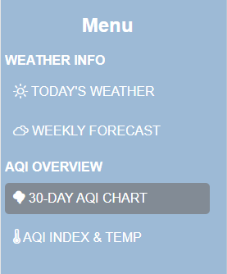

 When we click Fetch Data button, 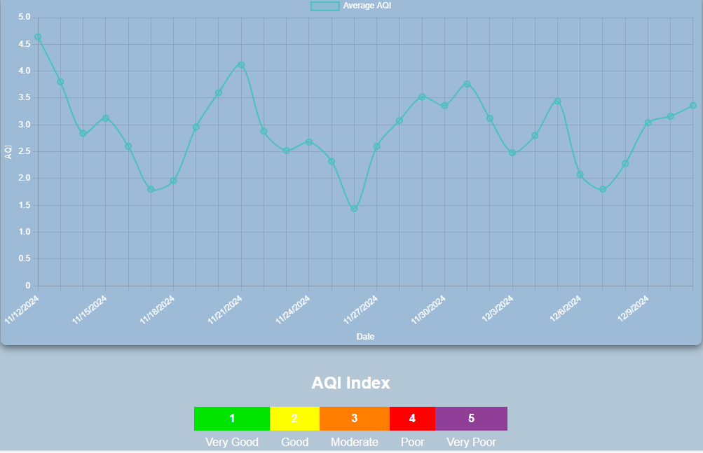

We can see the average AQI for the past 30 days in a chart format.

Note: Fetching this data may take a few seconds, which is a drawback I hope to improve.

**AQI INDEX & TEMPERATURE**

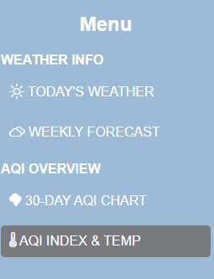

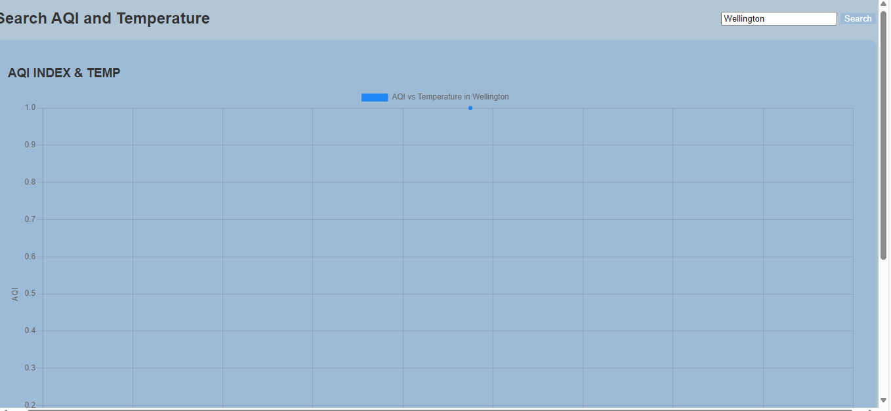

This page allows users to search for a city’s AQI index and temperature by entering the city name in the search bar.

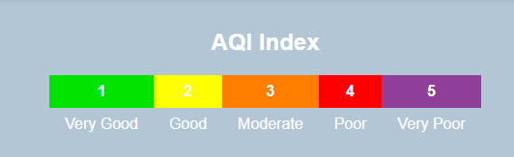

This is AQI level description by OpenWeather API.